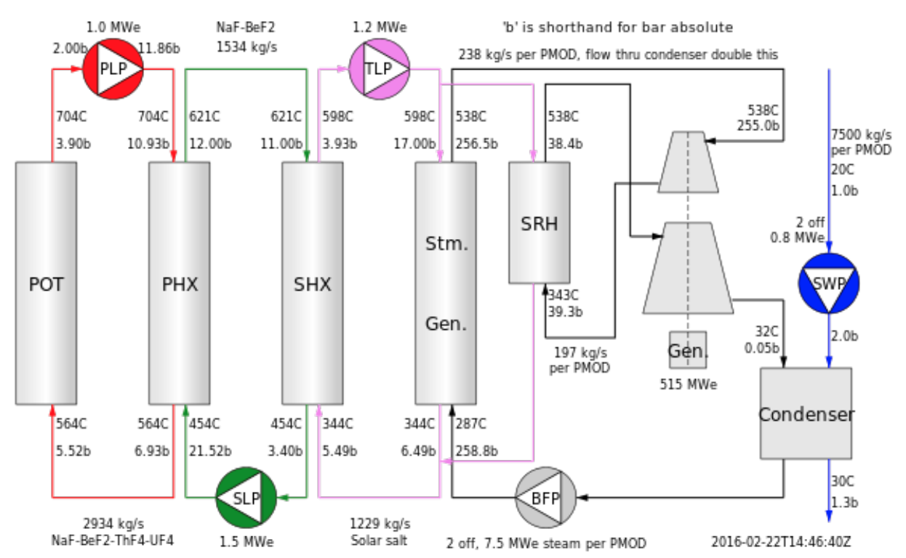

Thorcon’s reactor consist of four loops. From left to right: POT (primary loop inside reactor), PHX (Secondary Salt Loop), SHX (Solar Salt Loop) and lastly the Supercritical Steam Loop 500consisting of the steam generator, steam reheat, electricity turbine generator and a condenser.

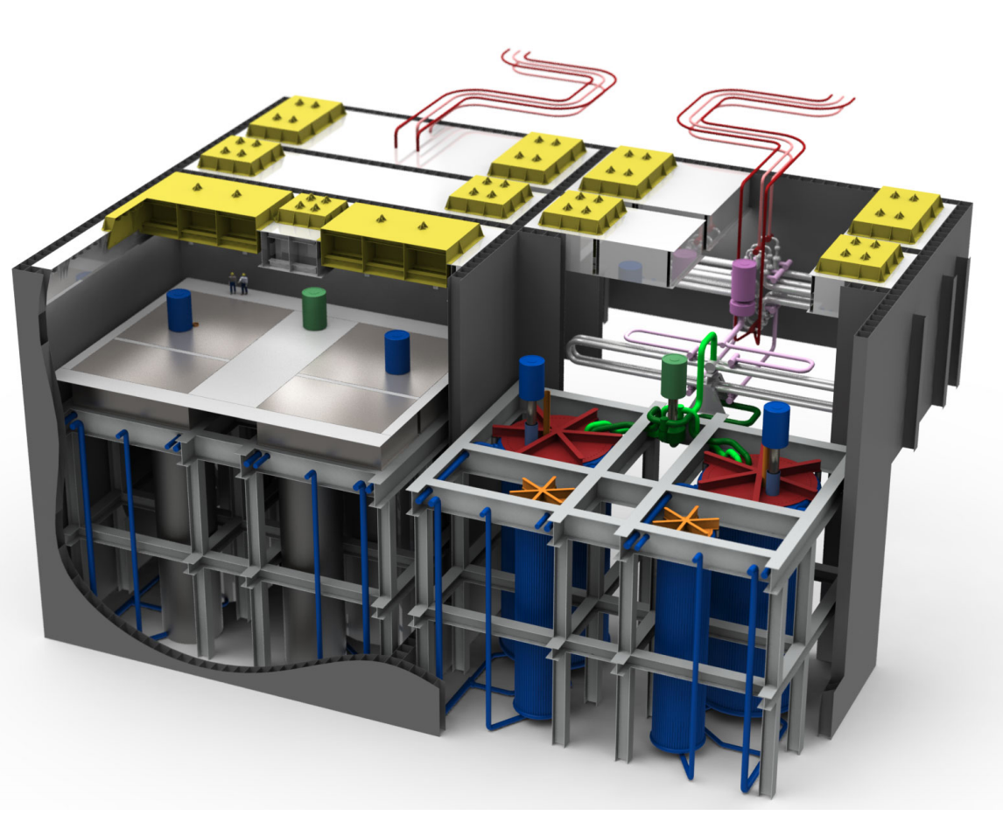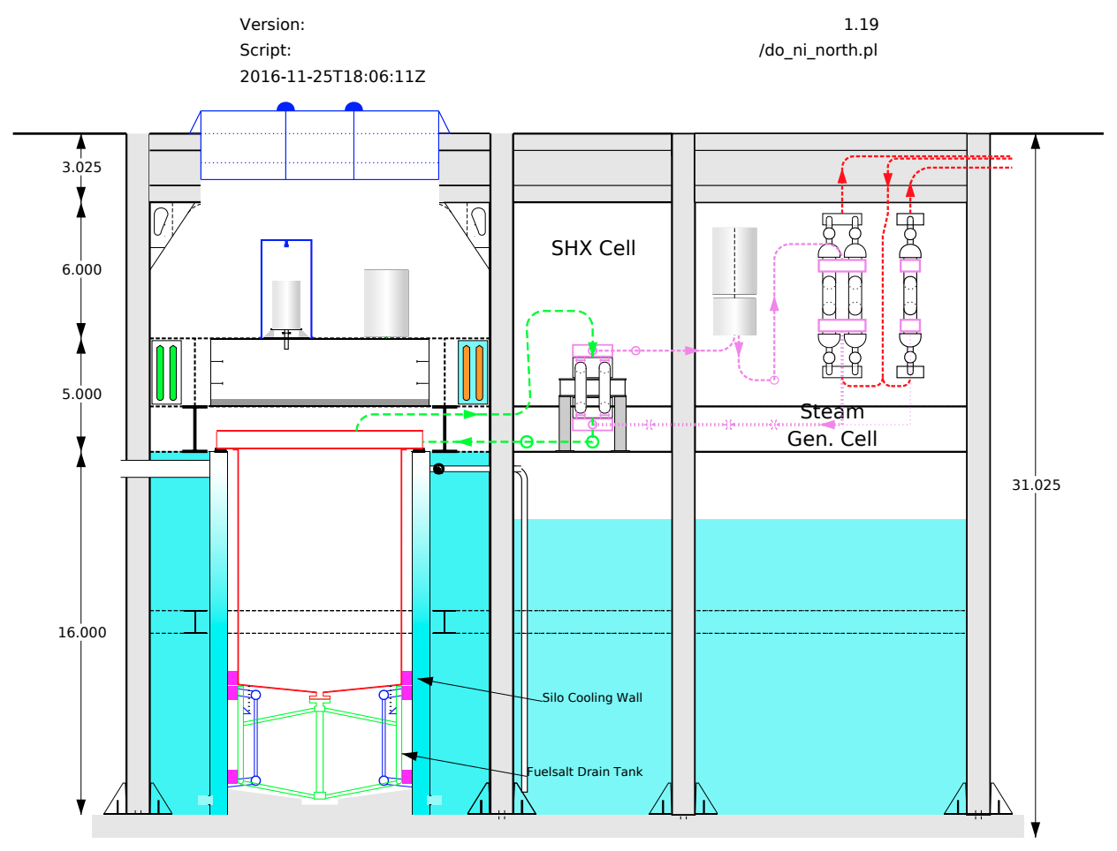

In this diagram the secondary salt loop is shown in green. It consists of a hot mixture of sodium and beryllium fluoride (no uranium or thorium) coming out the primary heat exchanger to a secondary heat exchanger (SHX). The heat is transferred to a mixture of sodium and potassium nitrate (solar salt - purple). This in turn transfers heat to the supercritical steam loop (red). The parameters of the loops are the following:

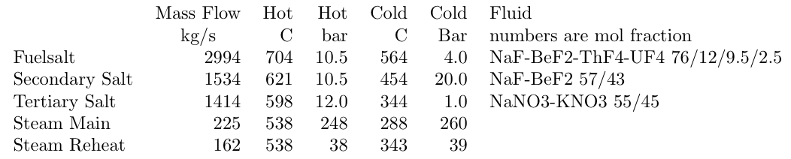

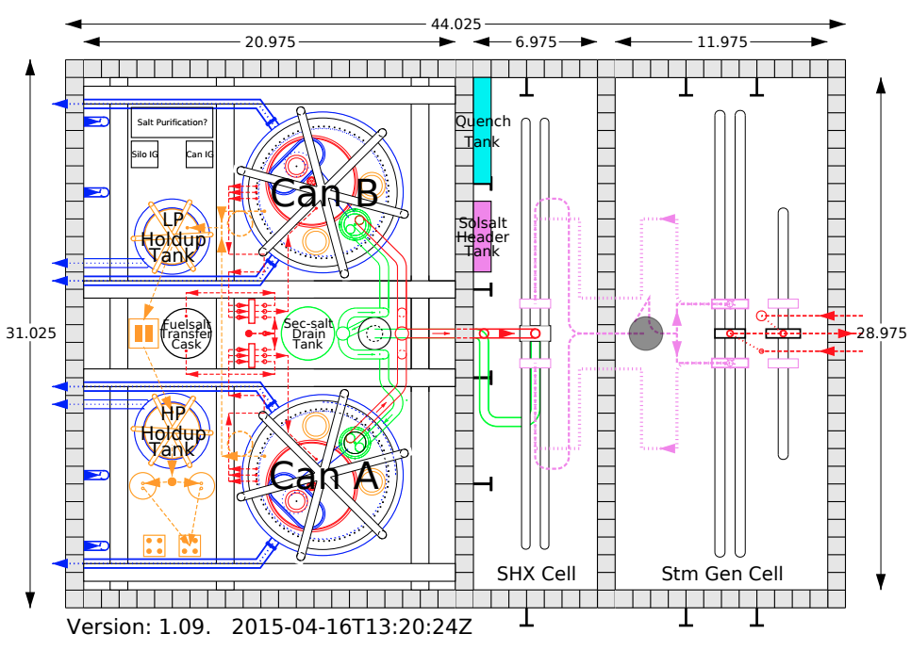

Each module is fitted with two off-gas holdup tanks shown in orange. The two tanks operate in series and are part of the offgas system that deals with volatile fission products, xenon and krypton. Beneath the Cans (Reactors) there is a drain tank in case molten salt fuel mix needs to be drain out of the reactor.



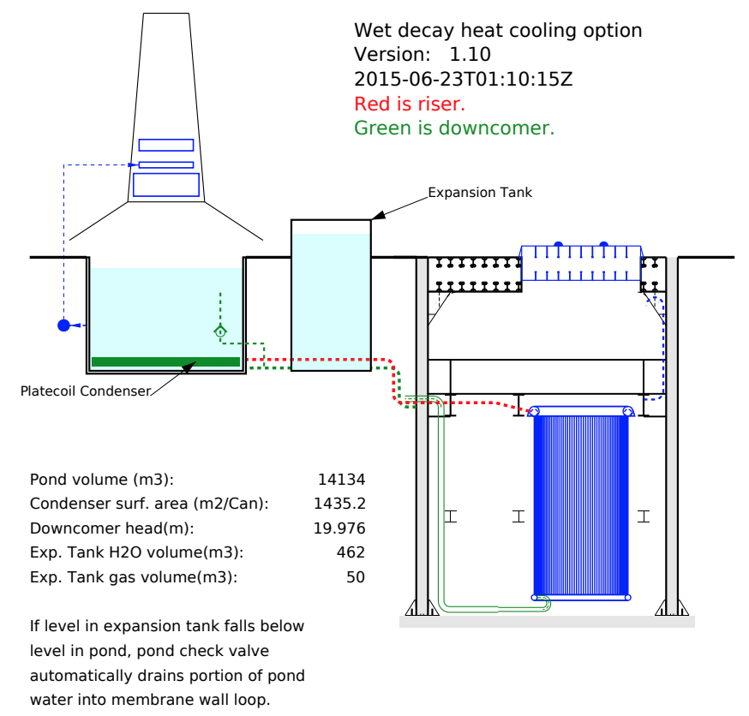

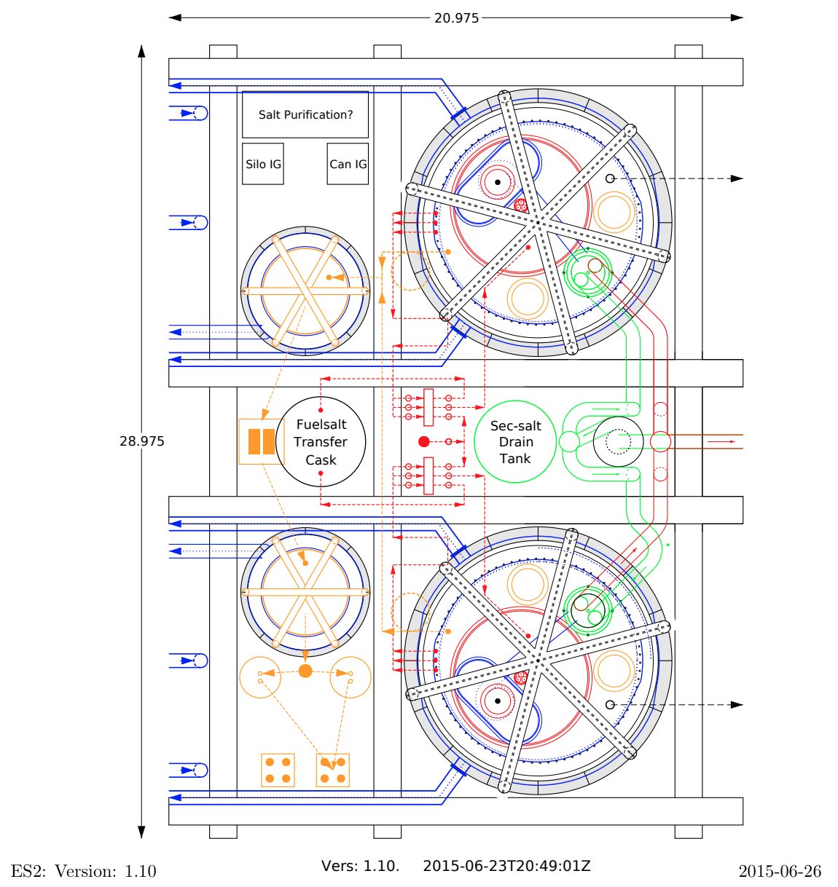

View of the grid block. Membrane wall piping at the top of the silo (blue): Risers are blue pointing to left. As part of the offgass system to deal with xenon, krypton an volatile fission products we have cryogenic separation unit (CSU) in orange in the orner. It consists of a verttical u loop with a finned nitrogen pipe in the center of the loop. Once every 24 hours the offgas flow is switched to the other CSU loop and the first loop is alowed to warm up.

\

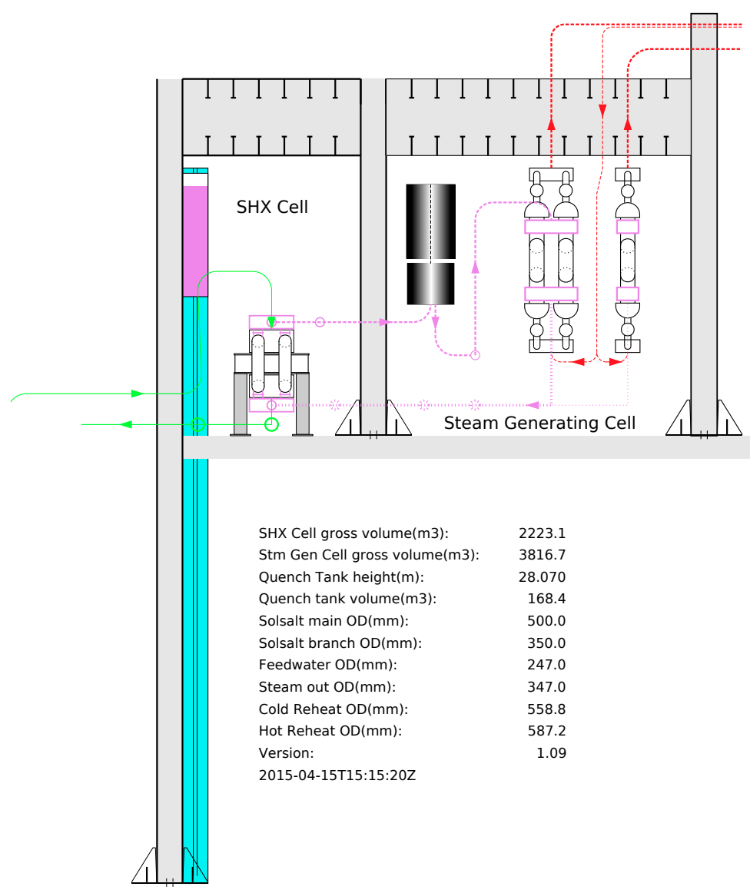

SHX and steam generating cell section.

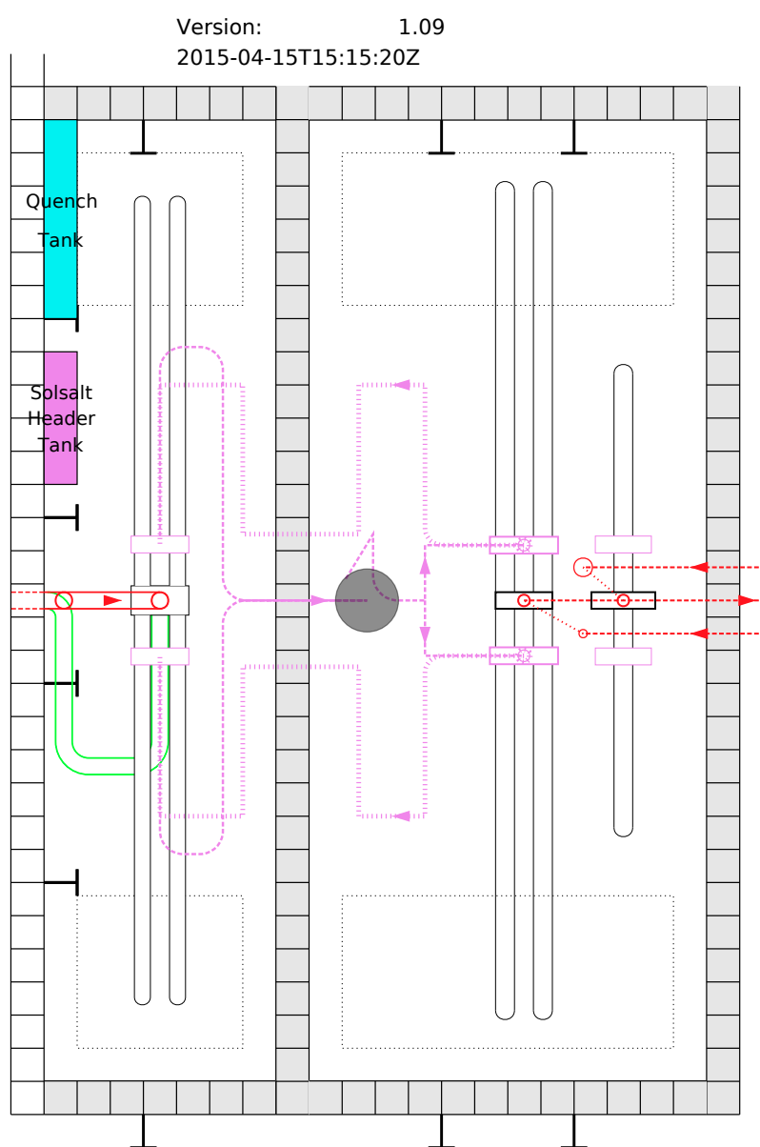

Plan view of SHX and steam generating cells.

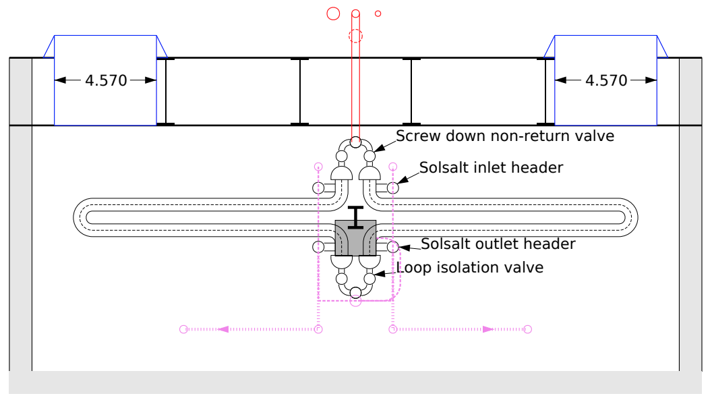

Profile of steam generating cell. Each steam loop is fitted with a quick acting isolation valve. Tues in the SHX are much stronger than the THX shell and the tubes in the PHX are much stronger than the SHX shell. The SHX shell is fitted with blow-out panels. All this is fitted to prevent a scenario where steam generator tubes rupture which causes a tub rupture in the SHX which also over-pressurizes and ruptures the phx tubes.